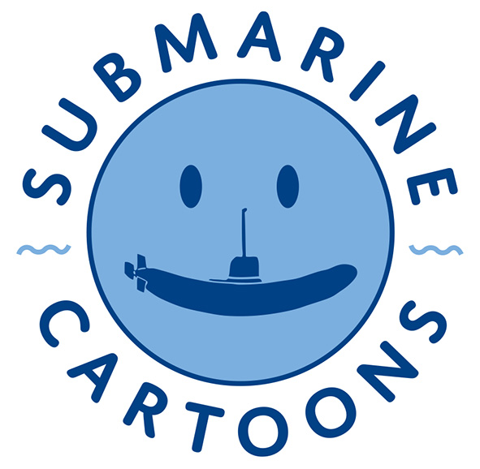
Podmornica karikature
PROPOZICIJE
Povodom 56. Međunarodnog kongresa podmorničara u Beogradu 21 – 26. maja 2019, Udruženje podmorničara Beograd i Udruženje karikaturista Srbije FECO organizuju međunarodni konkurs karikatura i izložbu na temu PODMORNICA (podmornice, posada, ronioci, torpeda, mine i dr)
Radove slati na e-mail adresu: submarine.cartoons@yahoo.com do 20. aprila 2019. (JPEG, 300dpi, A4, max 4MB po radu)
Nagrade:
1. nagrada – 300 evra i diploma
Specijalna nagrada Nikola Otaš* - 300 evra i diploma
2. nagrada – 200 evra i diploma
Selektovani učesnici dobiće štampani katalog ako pošalju i svoju poštansku adresu, a biće dostupan i u PDF formatu na sajtu udruženja karikaturista www.fecoSerbia.com
Organizator zadržava pravo upotrebe prispelih radova u cilju promocije udruženja, konkursa i izložbe.
*Nagrada Nikola Otaš (1960-2016) posvećena je podmorničaru i istaknutom karikaturisti, potpredsedniku FECO Serbia.

Submarine cartoons
REGULATIONS
Apropos 56. International Submariners Congress, Belgrade, Serbia, from May 21-26, 2019, Union of Submariners Belgrade and Union of Cartoonists of Serbia FECO organize International cartoon contest and exhibition on theme SUBMARINE (submarines, crews, divers, torpedoes, mines etc.)
Send cartoons at e-mail adress:
submarine.cartoons@yahoo.com till April 20, 2019 (JPEG, 300dpi, A4, max 4MB per one cartoon)
Prizes:
1st Prize – 300 euro and Diploma
Special Prize Nikola Otas* – 300 euro and Diploma
2nd Prize – 200 euro and Diploma
Selected cartoonists will get a printed catalog if they send their postal adress or could download catalog in PDF format from website www.fecoSerbia.com
Organizator could use cartoons for promotional purpose of the unions, contest and the exhibition.
*Special Prize Nikola Otas (1960-2016) is dedicated to submariner and prominent cartoonist, vice-president of FECO Serbia.

